Enrolment Forms
  - September 2024
To start a placement at Camphill Wakefield, it is vital we have all the necessary information to keep every student safe and provide the best possible care, support, and education. To collect this information, there are several forms to fill in.
We recognise that we are asking for a lot of information, and it is easy to lose track of what forms you have completed. We hope this checklist helps you to keep track.

☐Previous Education and Future Aspirations
☐ Medical Matters
☐ Support Needs
☐ Consent
☐ Contact Details
☐ Free College Meals

Please click on the name of the form to go to the page containing information relating to each form, as well as a link and a QR code that will take you to the form.
If you require a paper copy of any forms, or support in completing these forms, please contact Morven Simpson by phoning 01924 255 281 or emailing admissions@camphill.ac.uk.

Previous Education and Future Aspirations
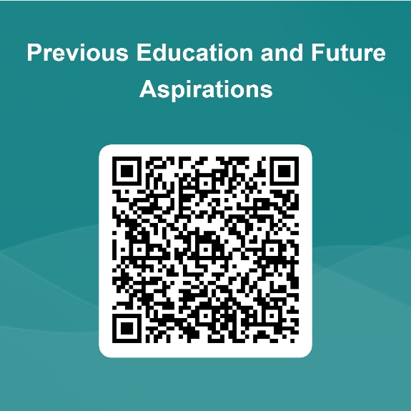
To help us understand your educational background and future goals, please fill in this form. We require information about your previous educational experiences, achievements, and any qualifications obtained. This information helps us tailor our support and resources to meet your educational needs and aspirations.

Medical Matters
It is vital that we have all the medical information and provisions necessary to appropriately care for our students. Please fill in this form to provide necessary medical information. If you have any questions regarding the information we are asking from you, please do not hesitate to get in touch with our admissions team by replying to this email.
The information you provide in this form will be used by the college to ensure we keep our students safe and meet their medical needs. Your details will not be passed onto a third party, unless stated otherwise (e.g. in the case of the VIP Hospital Passport). We are committed to ensuring that the personal and sensitive information that we hold about you is protected and kept safe and secure. We have measures in place to prevent the loss, misuse, or alteration of your personal information.
Please note:
- An up-to-date tetanus vaccination is required. If you are unsure of the date of the last tetanus booster, please contact your GP. If a student has not completed the full vaccination course, we recommend that they have a tetanus booster as soon as can be arranged.
- If a student is epileptic, we require an up-to-date epilepsy protocol from their epilepsy nurse or consultant. This must have been updated within the last six months. A student cannot attend until this is in place.
- If a student already has an annual Hospital VIP Passport, please enclose a copy, or arrange for it to be brought in so that we can make a copy and return it. This is invaluable if an ambulance or visit to A&E is necessary. A blank copy is attached to this email.
- If a student has any known allergies or intolerances, please provide medical evidence from a qualified professional. This is to ensure all information is correct and consistent. A student cannot attend until we have this on record.

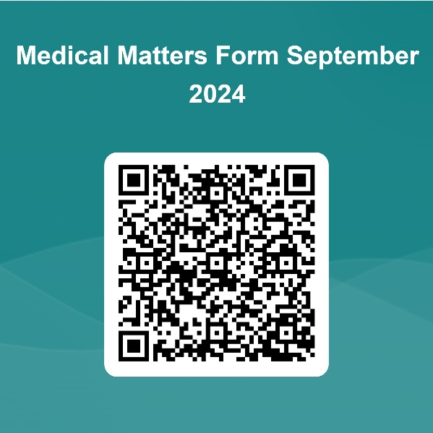
Please also ensure that, if a student takes any regular medicines during the daytime, they come with at least a full month's supply. The medication must have unaltered pharmacy dispensed labels attached. If a student has any medication with an 'as needed' direction, these should be accompanied by a written or emailed note from the GP describing when / how to use.

Support Needs
It is essential to provide us with detailed information about the support needs of the student to ensure we can offer the appropriate care and support. Please fill in this form so that we can collect information about special educational needs, disabilities, and other support requirements. The information you provide will help us create a personalised support plan to enhance the student's learning experience and well-being.


Consent
Consent is required for a variety of things at Camphill Wakefield. We gather consent from students to ensure that their rights and autonomy are respected, and that any decisions made about their education and support align with their individual needs and preferences.
The consent form is for the student to complete if they are 16 and over and have capacity. More information on how to support people to make decisions in line with the Mental Capacity Act is available from mencap.org.uk/advice-and-support/mental-capacity-act
A more accessible version of the form is available here. If the digital version cannot be completed by the student, please return this paper form to Camphill Wakefield.
If, despite support, the student has been unable to make these decisions, this form should be completed by a parent / carer.
Consent can be withdrawn or updated at any time by contacting Camphill Wakefield.

Photos/Videos/Sound Recordings
Please note, some photos and videos collected by the school are NOT processed based on consent (i.e. non optional for identification purposes) and we rely on another lawful basis. Further details can be found in our Privacy Notice.
Please note, where you have consented to the uses listed below, your name may be published alongside the photos and videos.
Should Camphill Wakefield wish to use photos and videos for additional purposes (other than those outlined above), specific consent will be sought. Examples may include usage of material by local or national press i.e. in newspapers or online news publications etc
*Please be aware, withdrawal of consent will not apply retrospectively to materials which have already been produced and are in circulation for example, a school prospectus. However, we will ensure that the material is not included in future publications where you have withdrawn consent.
If you have any questions, please do not hesitate to get in touch.
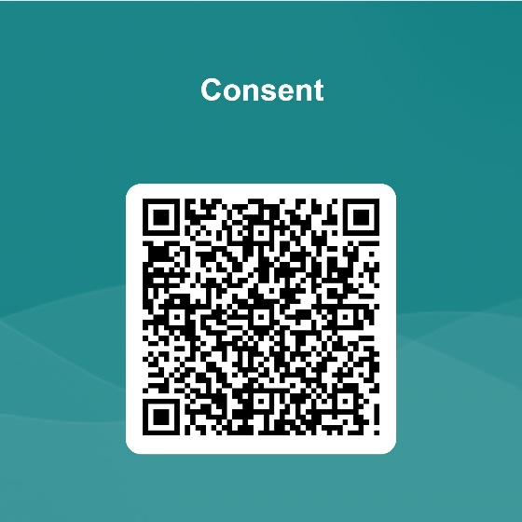

Contact Details
We follow guidelines issued by Wakefield Safeguarding Children Partnership and Social Care Direct (Safeguarding Vulnerable Adults). Our policy requires us to have on record at least two main contacts and alternative methods of contact for these emergency contacts. Please fill in this form to provide these details. We will only use the second contact in an emergency situation.
We appreciate you may have already provided this information as part of the admissions process, however, it is still important to fill in this form so that we can ensure we have the most accurate and up to date information.
If your young person is staying somewhere different to their home address (e.g. at respite, with other family members), please inform us and provide contact details in case of an emergency, or in case of transport issues.

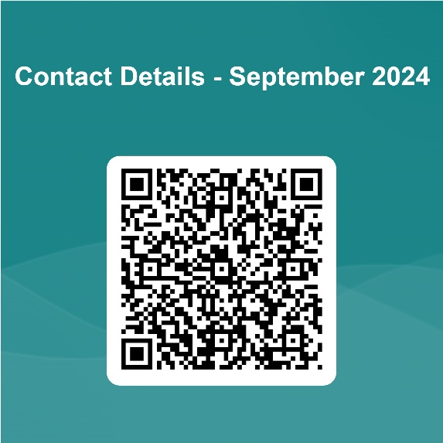
Free College Meals
Some students at Camphill Wakefield are eligible for free college meals based on the receipt of certain benefits.
A student may be eligible for free college meals if they, or their parent / carer, are in receipt of one of the following benefits:
- Income Support
- Income-based Jobseeker’s Allowance
- Income-related Employment and Support Allowance
- Support under Part VI of the Immigration and Asylum Act 1999
- The guaranteed element of Pension Credit
- Child Tax Credit (provided you’re not also entitled to Working Tax Credit and have an annual gross income of no more than £16,190)
- Working Tax Credit run-on - paid for 4 weeks after you stop qualifying for Working Tax Credit
- Universal Credit - if you apply on or after 1 April 2018 your household income must be less than £7,400 a year (after tax and not including any benefits you get).

To confirm that your young person is eligible for college meals, we need some information about you and your young person. To provide this information, please complete this form.
The form will ask you to upload required supported documentation / evidence. Provision of this evidence is a requirement of the funding process; it does not mean we doubt your eligibility. If we do not have the evidence to support your claim, there may be a delay in processing, and, potentially, providing meals.
It may be that, at the moment, your family is not eligible. Should your circumstances, and thus your eligibility change at any point during the college year and you would like to receive a college meal, please get in touch by emailing reception@camphill.ac.uk.

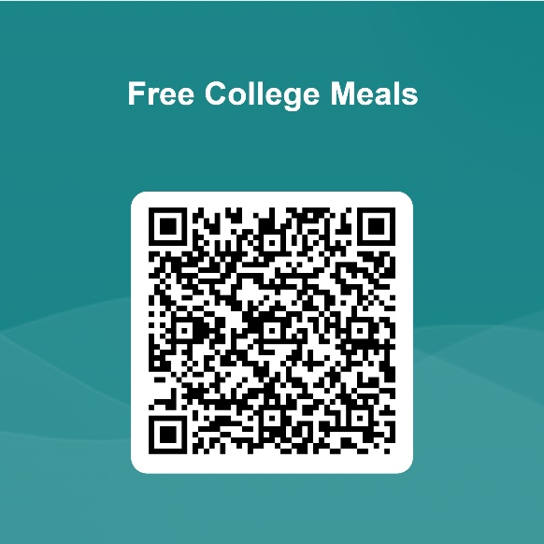

Transport
If you or your young person is in receipt of one of the above listed welfare benefits, you can also apply to the Local Authority to have the post 16 transport charges cancelled.
For Wakefield, please ring the Home to School Transport Team on (01924) 305675 or email hst@wakefield.gov.uk for more information

For Leeds, please request an application form by emailing send.transportapplications@leeds.gov.uk or leaving a voicemail on 0113 535 1990. Please return completed forms by email to: send.trannsportapplications@leeds.gov.uk
Or return you form by post to:
The SEND Transport Assessment Team
Children's and Families Services
Civic Hall
Calverley Street
Leeds
LS1 1UR

For Kirklees, you can apply online at School transport | Kirklees Council, or get in touch with the School Transport Team by emailing senact@kirklees.gov.uk or phoning 01484 465 888.

For Barnsley, the application form can be filled online at School travel for children with special educational, disability or mobility needs (SEND) (barnsley.gov.uk)
or contact the transport team by phoning 01226 774191

For Calderdale, get in touch with the transport team by phoning 01422 393 532 or emailing transport@calderdale.gov.uk

Bursaries
Post-16 bursaries are also available to help students to continue in education where they would otherwise be prohibited from doing so on financial grounds. Please see the attached document Bursary Guidance for Parents/Carers for full details of the scheme, including how to apply.

